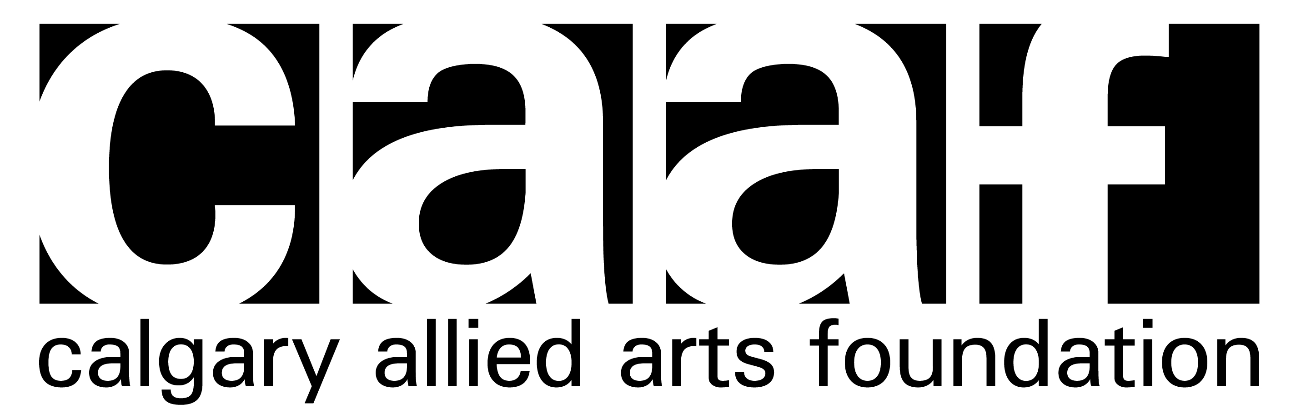

PRESIDENT’S REPORT 2
FISCAL YEAR: JULY 2014 – JUNE 2015 2
FINANCIAL REPORT 3
GALLERY 505 REPORT 5
RESIDENCY COMMITTEE REPORT 6

PRESIDENT’S REPORT

FISCAL YEAR: JULY 2014 – JUNE 2015

Over the last year, the Calgary Allied Arts Foundation, or “CAAF,” has fulfilled its mandate to promote and support the visual arts in Calgary through two core programs, the CAAF Residency Program and Gallery 505.

We lease one studio in the Art 4/5 studios in the old “Cannery Row” building on 10th Ave SW, and through a juried process award approximately six artists residences of 1-3 months. Our residency program has now been operating for over eight years, which has provided over 65 emerging and mid-career artists the opportunity of focussed time in a studio space with financial support. Artists also have the opportunity to open their studio for a public reception of their work at the end of their term.

We are now actively programming Gallery 505 with works from the City of Calgary’s Public Art Collection. In addition to showing works from the Public Art Collection, we will start to program the gallery space with select works of CAAF’s past resident artists. We started this fiscal year with our second show, entitled “Artists by Artists,” that ran through the summer and fall of 2015. Daniel Lindley was our volunteer curator for this show.

CAAF is mid-way through writing a history of the Calgary Allied Arts Foundation, which will be authored by Nancy Townshend. We look forward to a completed work in the fall of 2016. We are grateful for the Alberta Historical Resources Foundation grant that supports the funding of this project.

We are in the process of applying to gain status as an official charity, as designated by the Canada Revenue Agency. We hope to be successful in this application in the upcoming year.

We sincerely thank our art administrator Cassandra Paul. Cassandra is responsible for the core operations of CAAF, and has been very effective in promoting the Foundation through social media and maintaining our webpage. We thank her for all the support she has given to CAAF. I wish to thank our outgoing board member and past Treasurer, Kevin Allen, who has volunteered for two full terms on the board, and has made a significant contribution to CAAF. We will miss him.
Tricia Leadbeater,
President

FINANCIAL REPORT
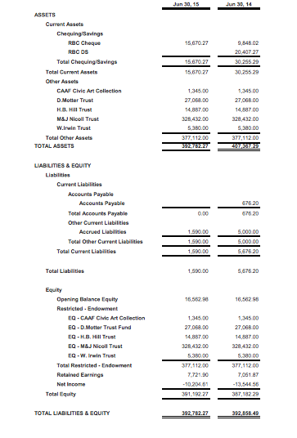
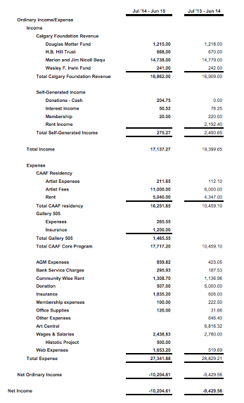

GALLERY 505 REPORT

For those of you that don't know, Gallery 505 was created in 2015 as a public art venue to be curated by the Calgary Allied Arts Foundation (CAAF). The space “Gallery 505” is a reference to its address at 505 – 8th Ave SW. It's a high traffic area and gives CAAF a greater street presence. Over the past year the gallery has extensively featured works from the Civic (Public) Art Collection. We were fortunate to have another curator (Daniel Lindley) assist with curating the space. Being the inaugural year we experimented with exhibition durations and found three shows annually is the right amount of time. We agreed to lengthening the shows from three to four months eases the commitment from the city and therefore we do not have to rely so heavily on their assistance. Additionally we agreed to feature more work from the CAAF residency artists for upcoming exhibitions as it is a great source for new work by practicing artists. All in all, our first year with Gallery 505 was a positive one and gained us more notoriety within the community and reconnected our relationship with The City and the Public Art Collection.

Shannon Norberg,
Gallery 505 Chair

RESIDENCY COMMITTEE REPORT

On December 15, 2013, the Residency Committee met to select residents for the calendar year, January 2014 to December 2015. The Residency Committee was composed of:
· Bruce Watson, Chair
· Cassandra Paul, Administrator
· Natalie McDonald
· Doug Haslam
· Paul Brown
The residents selected for fiscal year 2014/15 were:
· Tammy McGrath, June-August 2014
· Tyler Klein, September 2014
· Jeremy Pavka, October-November, 2014
· Bogdan Cheta, December 2014
· Kyle Beal, January-February, 2015
· Caitlyn Thompson, March 2015-April 2015
· Natasha Jensen, May 2015-June 2015
Of note, the residents from June to December, 2014 were the last to occupy the Art Central studio space. All subsequent residencies were held at the 4Five studio space at #503 319 – 10 Avenue SW
In the third week of October, 2014, the residency committee met in the third week of October, 2014 to select six residents for our 4/5 studio space for Jan-December, 2015.
While the following does not pertain to the fiscal year, the Residency Committee would like to thank Cassandra Paul for her considerable work for the committee and wishes her luck in her new position at ACAD, and we would also like to welcome Judy Ciccaglione.

Bruce Watson,
Residency Committee Chair

