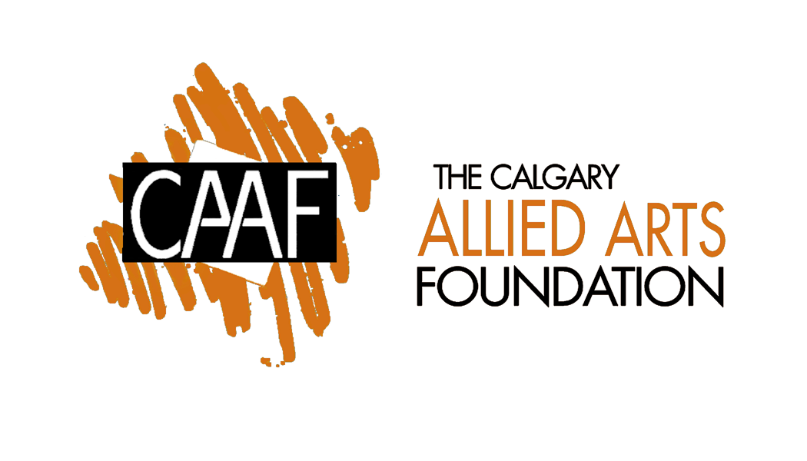

CALGARY ALLIED ARTS FOUNDATION
2011/ 2012
ANNUAL REPORT

2011 - 2012 ANNUAL REPORT

TABLE OF CONTENTS

PRESIDENT’S REPORT

CIVIC COLLECTION COMMITTEE REPORT

PROGRAMMING COMMITTEE REPORT

NOMINATIONS

TREASURER’S REPORT (UNDER SEPARATE COVER)

PRESIDENT’S REPORT

Over the last year, the Calgary Allied Arts Foundation board has actively continued to promote and encourage the visual arts in the Calgary Region by engaging the public and individual artists through the st[Art] Artists Residency Program by providing funds and volunteer time to the Civic Art Collection.

This year has seen our Treasurer Kevin Allen take on the significant responsibility of the administration of the organization with the purpose of more clearly defining the roles and responsibilities that a future contract administrator would take on. The Foundation is very grateful to Kevin for his dedication and willingness to provide his time and skills to this task.

Recently, the Foundation has begun the process of re-establishing its charitable status with the greatly appreciated aide of volunteer Cheery Mah. This will allow CAAF to provide tax receipt to donors in the future and make the process of accessing funds much simpler.

Most recently the Calgary Allied Arts Foundation has applied for and received a Calgary Arts Development Authority Induction Grant that puts the organization in position to obtain on-going support from CADA. Money from this grant will be used to pay for a contract administrator to take care of the ongoing activities of the organization.

Ongoing developments include discussions with a Calgary philanthropist regarding the creation of a pop-up gallery in a ground floor space of a downtown office building for the purpose of exhibiting work curated by CAAF from such sources as Residency Program artists and the Civic collection.

As a member of the Artist Residency Committee I have also been involved in the selection and scheduling of artists for the artist residency program.

I would like to thank the current board members for their hard work and dedication to the programs of the Calgary Allied Arts Foundation and look forward to working with new board members in the on-going development of the organization

Respectfully Submitted,

Doug Haslam
President

Collection Committee Annual Report

for the fiscal year ended

June 30th, 2012

The traditional job of this committee is to spend a budgeted portion of the annual earnings of CAAF’s endowments on the purchase of artworks and the donation of them to the Calgary Civic Art Collection. A few years ago the City adopted a public art policy which created a Civic Art Collection Committee composed of two voting members from CAAF, two voting members from the Public Art Board, and two non-voting members from City’s Public Art Program, Quyen Hoang and Barbara Greendale. This committee is charged with making purchases for the collection using the CAAF funds and deciding on any donation proposals received by the City.

During the previous fiscal year the committee has completed a curatorial review of the collection. Based on the needs of the collection and the amount of the available funds the decision of the committee was to focus the collecting on the work of emerging artists. The committee evolved a process of working, which includes list making, research, suggestion presentation, studio visits and ultimately the bringing of formal proposals before the committee for decision.

The result for this year has been the purchase of works by Bee Kingdom, Katrina Chaytor and Teresa Posniak. Several donations of works were also accepted.

During the year, however, a number of concerns about this mechanism for collecting have arisen. The main difficulty is the use of a considerable number of volunteer hours from the committee members and work hours from the Public Art Program employees to purchase works with relatively few dollars. Even with non-purchased works the time required to add works to the collection is lengthy. All require transfer paperwork, condition reports and consideration for their location. Many require maintenance and preparation for display. The current workload generated by the committee’s activities is overloading the Public Art Program employees excessively.

To resolve this situation the City has proposed the dissolution of the Civic Art Collection Committee and its replacement with a mechanism similar to that used by other groups within the Public Art Program to purchase works. This would probably involve open or invitational calls for submission organized by Quyen Hoang who has significant curatorial experience and expertise.

The CAAF board has directed the CAAF Collection Committee to again enter waiting mode until the City has finalized a new collection mechanism. At that time CAAF could direct the committee to channel funds to that mechanism or to consider other Calgary art-collecting institutions as possible recipients of our donations.

- submitted by the Committee Chair, Paul Brown

ST(ART) RESIDENCY COMMITTEE REPORT

Since its inception in 2006, CAAF has had 56 artists take part in the St(art) Residency Program. The space at Art Central and a historic warehouse located at 319 - 10 Avenue SW have been used specifically for artist residencies and the exhibition of work. Alberta visual artists of all career stages are eligible and encouraged to apply.

The St(art) Residency Committee selects residents of the program based on proposals that they have submitted through a public call for applications. Each residency is at least one month in duration and no longer than three months. Rental of space, artist’s fee and promotional fee are provided to residents.

Unfortunately, due to financial restraints, CAAF has had to continue to sublet the 319 - 10 Avenue SW location for the 2012-13 fiscal year. In July of 2013, CAAF will reconsider the space.

In keeping with the specifications of the Nichol endowment fund, CAAF is advancing and promoting visual arts in Alberta by providing a space in which Albertan artists can create and show their art.

2012 – 2013 Budget
Estimated Monthly fees

Studio Rental $400.00
Artist Fee $500.00
Invite/ opening $100.00
Total monthly fees $1,000.00
Total Annual Fees $12,000.00

Submitted,

Lauren Simms
Chair, St(art) Residency Committe

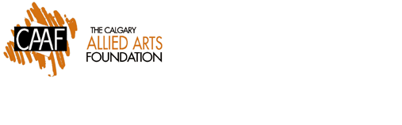
NOMINATIONS FOR
Calgary Allied Arts Foundation (CAAF)
Board of Directors 2012-2013

Nominees for Board of Directors-1st Year first term

Shannon Williamson Ordinary Member

